Thursday, July 11, 2019
HOT FROM FOX...

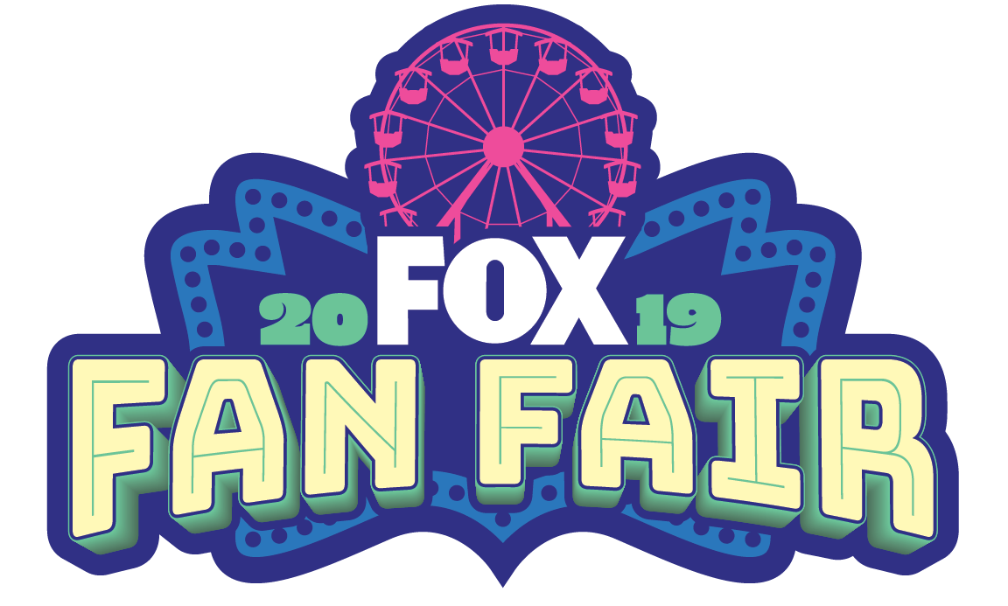

FOX LAUNCHES INTO SAN DIEGO COMIC-CON 2019 WITH
DEBUT OF FIRST ANNUAL “FOX FAN FAIR”

MULTIPLE ALL-NEW ACTIVATION SPACES BRING FOX ANIMATION DOMINATION TO LIFE WITH INTERACTIVE EXPERIENCES FOR FAN-FAVORITE SERIES

CATCH THE ULTIMATE RIDE ON THE MUST-SEE 70-FOOT-TALL FOX FERRIS WHEEL,
OVERLOOKING ALL OF DOWNTOWN SAN DIEGO

ENJOY CLASSIC CARNIVAL ACTIVITIES WITH A FOX TWIST AND
CHALLENGE YOUR FRIENDS IN SUPER-SIZED LAWN GAMES,
PLUS FREE TREATS, LIMITED EDITION GIVEAWAYS AND MORE.

SHARE YOUR COMIC-CON EXPERIENCE WITH MULTIPLE AUGMENTED
REALITY EXPERIENCES AND EXCLUSIVE SNAPCHAT FILTERS

CATCH EXCLUSIVE FIRST LOOKS AND ADVANCED SCREENINGS FOR
SEVEN FOX SERIES, INCLUDING NEW SERIES “BLESS THE HARTS,” “NEXT” AND “WHAT JUST HAPPENED??! WITH FRED SAVAGE”; AND RETURNING FAVORITES
“THE SIMPSONS,” BOB’S BURGERS,” “FAMILY GUY” AND “THE ORVILLE”

FOX “ANIMATION DOMINATION” FAN FAIR 2019

Where: Children’s Museum Park & Children’s Park
200 W. Island Ave., San Diego, CA 92101
Cross streets at Front Street and West Island Ave.

When: Thursday, July 18 – Sunday, July 21

Hours: Thursday: Noon – 8:00 PM
Friday: 10:00 AM – 8:00 PM
Saturday: 10:00 AM – 8:00 PM
Sunday: 10:00 AM – 1:00 PM
*Note: From Thursday – Saturday, select activations at Children’s Park to close at 6:00 PM.
-more-
“FOX FAN FAIR” AT SAN DIEGO COMIC-CON 2019 – Page 2

FOX is going BIG in its return to San Diego Comic-Con! The inaugural FOX FAN FAIR 2019 is taking over two all-new activation spaces totaling over 24,000 square feet and located across from The New Children’s Museum (at West Island Ave. and Front Street). The network is highlighting its all-new FOX ANIMATION DOMINATION Sunday night block, featuring fun twists on popular amusement rides and games all themed to fan-favorite animated series, THE SIMPSONS, BOB’S BURGERS, FAMILY GUY and all-new addition BLESS THE HARTS. Get ready for all the FREE festivities, including a massive 70-foot-tall Ferris wheel – the must-see attraction with spectacular views overlooking the convention center and San Diego skyline. Complete with an array of classic carnival games and competitions – including Water Gun Shoot Out, Sunday Slam, Super-Sized Stacking Tower, Giant Four-In-A-Row, Oversized Corn Hole and ANIDOM Bucket Ball – there also will be sharable AR experiences and a soft-serve ice cream truck providing sweet treats and water to keep fans of all ages cool. Fans also can pick up free limited-edition FOX ANIMATION DOMINATION gifts, including lanyards, sunstache glasses, collectible button series, bandanas and more. Follow @FOXTV to find out when cast members and producers from each of these shows will make in-person appearances at the experiences. Use #FOXSDCC to join the conversation.

Press Contact: Annie.Geffroy@fox.com (Cell: 858-229-0303)
Mallory.Morehead@fox.com (Cell: 818-821-7767)
Elise.Prado@fox.com (Cell: 619-254-8835)

EXCLUSIVE LIMITED-EDITION COMIC-CON ITEMS
Drop by the FOX FAN FAIR space daily and earn limited-edition ANIMATION DOMINATION items. Giveaways are while supplies last and include lanyards, a collectible button series, bandanas and Sunstache character glasses.

PANELS & SCREENINGS SCHEDULE (by day)

FRIDAY, JULY 19
Panels:

BLESS THE HARTS 11:00 – 11:45 AM – Indigo Ballroom (Hilton Bayfront)
From the network that brought you the Simpsons, the Griffins and the Belchers, now comes the Harts! FOX’s new half-hour animated comedy, BLESS THE HARTS, features everyone’s new favorite good ol’ Southern family.

Meet hard-working Jenny Hart (Kristen Wiig), who supports her lottery scratcher-obsessed mother, Betty (Maya Rudolph), and her witty, creative daughter, Violet (Jillian Bell). With the help of her eternally optimistic, dreamer boyfriend, Wayne (Ike Barinholtz), they hope to one day achieve the American dream. They might struggle to make ends meet, but they’re already rich in friends, family and laughter. Don’t miss an exclusive first look into your next animation obsession with the executive producers, including Emmy Award winner Emily Spivey (“Wine Country,” “Parks and Recreation,” “Saturday Night Live”) and Academy Award winners Phil Lord and Christopher Miller (“Spiderman: Into the Spider-Verse,” “The LEGO Movie,” “21 Jump Street”), as well as the all-star cast behind the Harts!

-more-

“FOX FAN FAIR” AT SAN DIEGO COMIC-CON 2019 – Page 3

BOB’S BURGERS 4:00 – 4:50 PM – Indigo Ballroom (Hilton Bayfront)
Always one of the most entertaining panels at Comic-Con, the Emmy Award-winning animated FOX series BOB’S BURGERS returns to San Diego with a few surprises in store! Creator and executive producer Loren Bouchard and executive producer Nora Smith will break news about the upcoming season, and the always-entertaining cast, including H. Jon Benjamin, Dan Mintz, John Roberts, Kristen Schaal, Larry Murphy and Megan Mullally, will have you howling with laughter. Don’t miss never-before-seen footage, followed by a lively panel discussion and audience Q&A.

WHAT JUST HAPPENED??! WITH FRED SAVAGE 5:30 – 6:30 PM – Room 6DE
Acclaimed director and television star Fred Savage cannot wait a second longer to share the world of “The Flare,” the most mind-bending, thrilling, edge-of-your-seat sci-fi show never created. “The Flare,” based on TJ Whitford’s classic series of sci-fi novels, “The Moon is the Sun at Night,” not only sizzled its way into living rooms nationwide, but also inspired FOX to create its first ever after-show, WHAT JUST HAPPENED??! WITH FRED SAVAGE. Join Fred, alongside stars of “The Flare,” including Shiri Appleby (“Roswell”), Kevin Zegers (“Fear the Walking Dead”), and Tyler Ritter (“Agents of S.H.I.E.L.D.”), as well as co-creators Matt Silverstein and Dave Jeser and director Jon Cassar (“24”), for a sneak-peek screening of the fourth episode of the after-show dedicated to exploring the fandom surrounding the “The Flare.” The half-hour hybrid comedy/talk show airs Sundays (9:30-10:00 PM ET/PT) on FOX. Screening to be followed by conversation moderated by Fred Savage and fan Q&A.

neXt 6:45 – 7:45 PM – Room 6DE
Catch the world premiere of neXt, a propulsive, fact-based thriller about the emergence of a rogue artificial intelligence that combines pulse-pounding action with an examination of how technology is invading our lives and transforming us in ways we don’t yet understand. Coming to FOX in 2020, neXt stars John Slattery (“Mad Men”) as a Silicon Valley pioneer who teams with cybercrime agent Fernanda Andrade (“The First”), to fight a villain unlike anything we’ve ever seen. Panelists to include creator and executive producer Manny Coto (“24”), executive producers and directors John Requa and Glenn Ficarra (“This Is Us”), Fernanda Andrade, Michael Mosley (“Ozark”), Jason Butler Harner (“Ozark”) and Eve Harlow (“Agents of S.H.I.E.L.D.”) for a moderated conversation and fan Q&A.

SATURDAY, JULY 20
Panels:

THE SIMPSONS Noon – 12:45 PM – Ballroom 20
Get inside insights and secret tips on the upcoming and unprecedented 31st season from Matt Groening, Al Jean, Mike B Anderson, Stephanie Gillis and the voice of “Lisa Simpson” – and panel moderator – Yeardley Smith. There WILL be freebies!

FAMILY GUY 1:40 – 2:15 PM – Ballroom 20
Join cast Seth MacFarlane, Alex Borstein, Mike Henry and executive producers Rich Appel, Alec Sulkin and Kara Vallow from FOX’s hit animated comedy, as FAMILY GUY celebrates its 20th anniversary! Take a look back at some of the show’s favorite moments over the last 20 years, plus a special sneak peek at the hilarity and hi-jinx in the upcoming season!
-more-
“FOX FAN FAIR” AT SAN DIEGO COMIC-CON 2019 – Page 4

THE ORVILLE 2:30 – 3:15 PM – Ballroom 20
From Emmy Award-winning executive producer and creator Seth MacFarlane, THE ORVILLE is back for Season Three and stopping in San Diego! Join the full crew of the U.S.S. Orville: Seth MacFarlane, Adrianne Palicki, Penny Johnson Jerald, Scott Grimes, Peter Macon, Jessica Szohr, J Lee, Mark Jackson and Chad L. Coleman, as well as executive producers David A. Goodman, Jon Cassar and Brannon Braga, to get an exclusive look back at some of their favorite, never-before-seen moments from Season Two and a special sneak peek at the new and exciting missions in the upcoming third season!

2019 AUTOGRAPH SIGNINGS
Cast and Producers from many FOX series will be signing autographs throughout San Diego Comic-Con and exclusive show mini posters will be distributed from Booth #4229.

Signings include:
BLESS THE HARTS Cast & Producers
BOB’S BURGERS Cast & Producers
WHAT JUST HAPPENED??! WITH FRED SAVAGE Cast & Producers
neXt Cast & Producers
THE SIMPSONS Cast & Producers
FAMILY GUY Cast & Producers
THE ORVILLE Cast & Producers

TWITTER
Fans can also receive updated announcements and information from each panel, the press room and other activities throughout San Diego Comic-Con, by following these series and joining the conversation by using #FOXSDCC and other hashtags as noted below:

SHOW | TWITTER (#Hashtag) | FACEBOOK
BLESS THE HARTS | @BlessTheHartsFOX (#BlessTheHarts) | BlessTheHarts
BOB’S BURGERS | @BobsBurgersFOX (#BobsBurgers) | BobsBurgers
WHAT JUST HAPPENED??! | @WJHonFOX (#WhatJustHappened) | WhatJustHappened
neXt | @neXtonFOX (#neXt) | neXt
THE SIMPSONS | @TheSimpsons (#TheSimpsons)  @HomerJSimpson  @ComicBookGuy | TheSimpsons
FAMILY GUY | @FamilyGuyonFOX (#FamilyGuy) | FamilyGuy
THE ORVILLE | @TheOrville (#TheOrville) | TheOrville

-more-

“FOX FAN FAIR” AT SAN DIEGO COMIC-CON 2019 – Page 5

MEDIA INFORMATION/CONTACTS (do not post)

For photos from FOX FAN FAIR 2019, you may visit foxflash at this link: http://www.foxflash.com/shows/fox-fan-fair-at-the-2019-san-diego-comic-con/

News and video content will be distributed to the media throughout the San Diego Comic-Con weekend.

For panel information and media questions, please contact the show publicist below, or Annie Geffroy (Annie.Geffroy@fox.com) and Marissa Deems (Marissa.Deems@fox.com).

SHOW | PUBLICIST | CONTACT
BLESS THE HARTS | Hayley Hindinger  Elise Prado  Nicole Crawford (TCFTV) | Hayley.Hindinger@fox.com  Elise.Prado@fox.com  Nicole.Crawford@fox.com
BOB’S BURGERS | Mallory Morehead  Chris Kaspers (TCFTV) | Mallory.Morehead@fox.com  Chris.Kaspers@fox.com
FAMILY GUY | Elise Prado  Nicole Crawford (TCFTV) | Elise.Prado@fox.com  Nicole.Crawford@fox.com
neXt | Annie Geffroy  Shari Rosenblum (TCFTV) | Annie.Geffroy@fox.com  Shari.Rosenblum@fox.com
THE ORVILLE | Todd Adair  Nicole Crawford (TCFTV) | Todd.Adair@fox.com  Nicole.Crawford@fox.com
THE SIMPSONS | Michael Roach | Michael.Roach@fox.com
WHAT JUST HAPPENED??! WITH FRED SAVAGE | Mallory Morehead  Shari Rosenblum (TCFTV) | Mallory.Morehead@fox.com  Shari.Rosenblum@fox.com
-FOX-

