WELCOME TO THE RED (WINE) PLANET!
“THE MARS BAR” OPENS ITS DOORS FOR A LIMITED FLIGHT IN LOS ANGELES TO CELEBRATE THE LAUNCH OF FOX’S ALL-NEW UNSCRIPTED COMPETITION SERIES STARS ON MARS

Out-of-This-World Fan Experience Invites Guests to Sip, Savor & Stargaze at the
Exclusive Mars-Themed Wine Bar Pop-Up ‘Launching’ in Hollywood on June 2nd

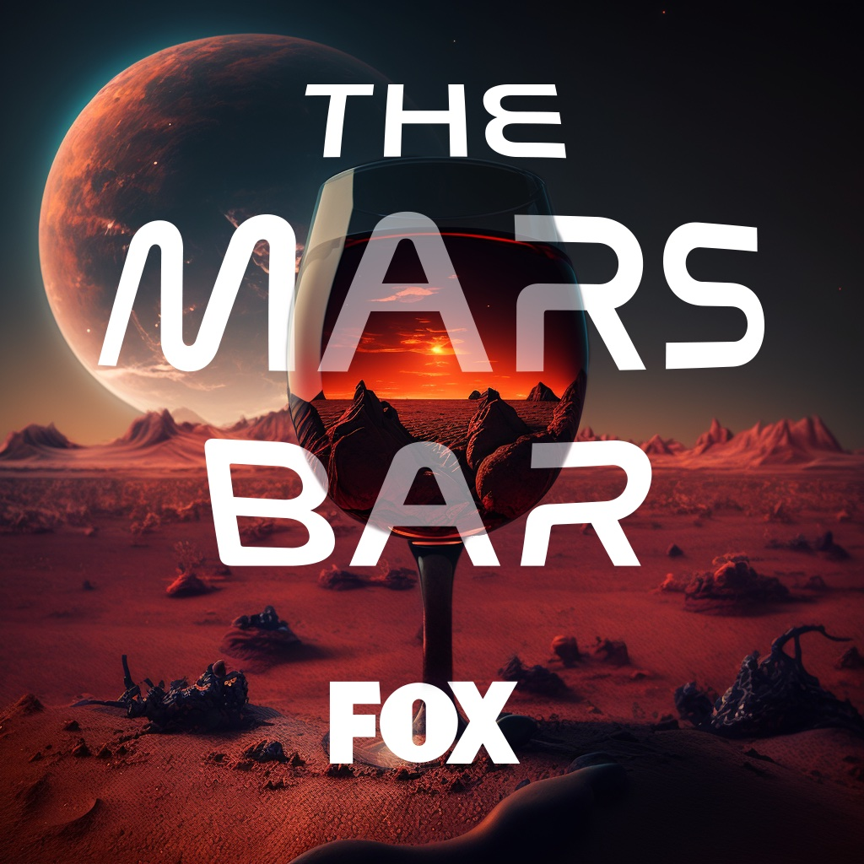

RESERVATIONS WILL OPEN ON TUESDAY, MAY 30TH AT 12:00 PM PST VIA TOCK: https://www.exploretock.com/themarsbar

Stars on Mars Will Premiere Monday, June 5 (8:00-9:00 PM ET/PT) on FOX

Click HERE for Photos (Courtesy of FOX)

Los Angeles, CA (Tuesday, May 30) - FOX is inviting all wine lovers, space enthusiasts and TV fans to the official opening of “The Mars Bar” - an exclusive hosted wine bar pop-up coming to Los Angeles to celebrate FOX’s highly anticipated new unscripted series Stars on Mars. “The Mars Bar” will temporarily take over the popular Scum & Villainy Cantina in Hollywood from June 2nd to June 3rd, offering guests the chance to experience the Red (Wine) Planet with series-inspired ‘Space Flights,’ astronaut charcuterie, exclusive content and “star” gazing in a fully immersive setting. Stars on Mars will premiere on Monday, June 5 from 8:00-9:00 PM ET/PT on FOX.

Upon entering “The Mars Bar,” guests will be able to sample a curated selection of space-themed wines, specially chosen to reflect the allure and unexpected moments of the new series. From rich, robust reds to crisp and refreshing whites, each glass will be a voyage of flavors that transport your senses to uncharted territories. Let the Mission Specialist Sommelier take you on a star-studded odyssey to "Mars" through a journey of the senses. Enjoy a tantalizing wine flight and catch a glimpse of the new season while you sip.

“As Stars on Mars counts down to its June 5th lift off on FOX, we’re inviting our fans to celebrate with the ultimate, two-day Hollywood launch party, complete with flights of red wine, of course,” said Jean Guerin, EVP of Publicity and Corporate Communications at FOX Entertainment. “’The Mars Bar’ is a fitting toast to this new competition series and the perfect send-off as our celebronaut crew prepares to embark on a hilariously out-of-this-world journey to the Red Planet.”

This summer, adventurous celebrities prepare for take-off to “Mars”, where they will live, eat, sleep, strategize and bond with each other in the same space station. During their stay, they will be faced with authentic conditions that simulate life on Mars, and they must use their brains and brawn – or maybe just their stellar social skills - to outlast the competition and claim the title of brightest star in the galaxy. The celebrities will compete in missions and will vote to eliminate one of their crewmates each week, sending them back to Earth. Cue the intergalactic alliances and rivalries. Stars on Mars will send these famous rookie space travelers where no one has gone before and reveal who has what it takes to survive life on “Mars.” The 12 celebronauts heading to “Mars” include Lance Armstrong, Natasha Leggero, Marshawn Lynch, Christopher Mintz-Plasse, Adam Rippon, Ronda Rousey, Tom Schwartz, Richard Sherman, Tinashe, Porsha Williams Guobadia, Tallulah Willis and Ariel Winter. Once on “Mars,” this group of stars will receive interstellar assignments from legendary actor and Star Trek icon William Shatner, who serves as Mission Control.

Reservations to attend the two-day “The Mars Bar'' experience are required for entrance and will be available for Los Angeles attendees beginning at 12:00pm PST on Tuesday, May 30 via Tock: https://www.exploretock.com/themarsbar. Additional details regarding the experience will be announced in the coming weeks.

Where: Los Angeles
When: Friday, June 2 and Saturday, June 3 from 12:00 PM – 8:00PM PT
Where: Scum & Villainy Cantina - 6377 Hollywood Blvd, Los Angeles, CA 90028
RSVP: https://www.exploretock.com/themarsbar

“The Mars Bar” experience was created by FOX in collaboration with NVE Experience Agency.

About FOX Entertainment
With a legacy spanning more than 35 years, FOX Entertainment is one of the world’s most recognizable media brands and a prolific content producer across its iconic broadcast network and both owned and third-party streaming platforms. Known for its independent, innovative spirit and provocative, groundbreaking storytelling, the company was reinvented in 2019 with the formation of FOX Entertainment. While maintaining its leadership in broadcast television (The Simpsons, The Cleaning Lady, Hell’s Kitchen, LEGO Masters), the company is actively building a portfolio of businesses and library of owned original content. To date, FOX Entertainment’s long-term growth strategy has included the acquisitions of award-winning animation studio Bento Box Entertainment (Bob’s Burgers, The Great North, Krapopolis, Grimsburg), entertainment platform TMZ, and global production studio MarVista Entertainment (The Way Home), as well as the formation of the culinary and lifestyle content venture Studio Ramsay Global (Next Level Chef, Gordon Ramsay’s Food Stars) in partnership with Gordon Ramsay. The company also established its in-house unscripted studio FOX Alternative Entertainment (The Masked Singer, I Can See Your Voice, Name That Tune), FOX Entertainment Studios (Animal Control) to develop scripted content and the worldwide content sales unit FOX Entertainment Global.
Media Contacts:
NVE Experience Agency
Brian Rubin
Brian.Rubin@experiencenve.com
Alexandra Amela
Alexandra.Amela@experiencenve.com

FOX
Jacqueline Gonzalez
jacqueline.gonzalez@fox.com
Taylor Nachreiner
Taylor.Nachreiner@fox.com

