FOR IMMEDIATE RELEASE Contact: Annie Geffroy
Thursday, Dec. 19, 2019 310-369-1425
annie.geffroy@fox.com

MEET THE 20 CONTESTANTS SET TO COMPETE ON
NEW UNSCRIPTED COMPETITION SERIES “LEGO MASTERS”
PREMIERING WEDNESDAY, FEBRUARY 5, ON FOX

Paired in Teams of Two, 20 LEGO®-Obsessed Contestants Put Their Building Skills to the Test

Will Arnett Hosts All-New Brick-Building Competition Series

Let the brick-building begin! 20 men and women have been selected to showcase their expert LEGO® experience in the new competition series LEGO MASTERS, premiering Wednesday, Feb. 5 (9:00-10:00 PM ET/PT) on FOX.

Hosted by Will Arnett, the series will put these contestants – ranging from ages 23 to 65, and hailing from every part of the country and all walks of life – to the test. Teams of two will compete against each other in ambitious brick-building challenges until the top teams face off for a cash prize, the ultimate LEGO® trophy and the grand title of LEGO MASTERS. Throughout the competition, Arnett, alongside expert judges, will encourage the builders and introduce incredible challenges, as one contestant pair is sent home each week, until the final duo is crowned LEGO MASTERS.

Meet the 20 LEGO MASTERS Contestants:

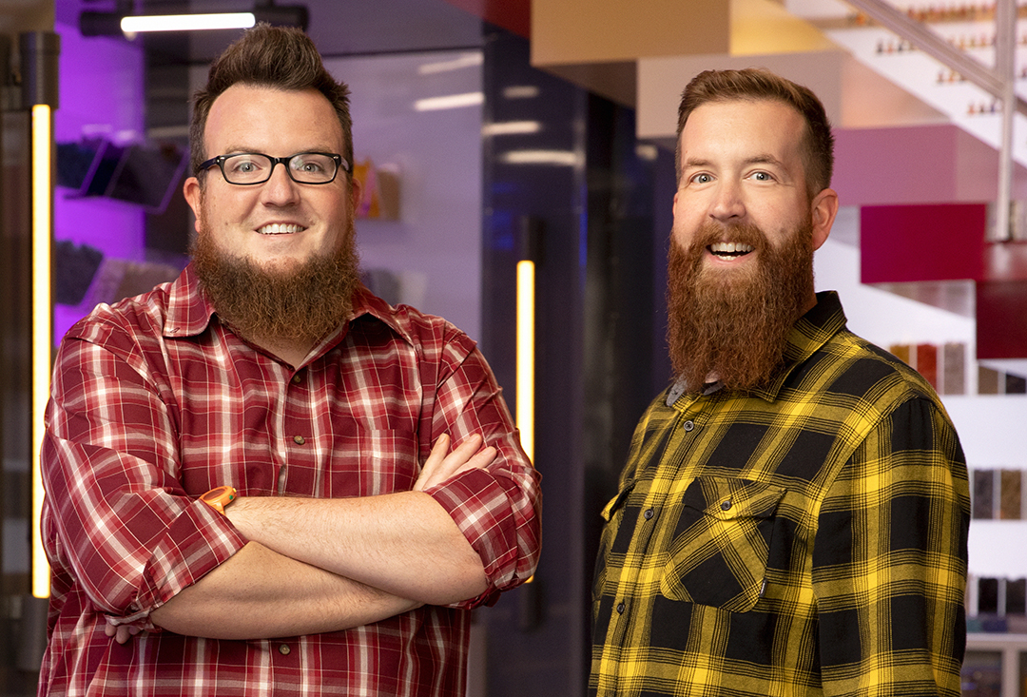 | BOONE & MARK  Age: 35 I 36  Home Towns: Troutdale, OR / Oregon City, OR  Occupations: Pre-K Teacher / HVAC Installer  Team Name: THE BEARDED BUILDERS  Strengths: Technical builds / Apocalyptic worlds

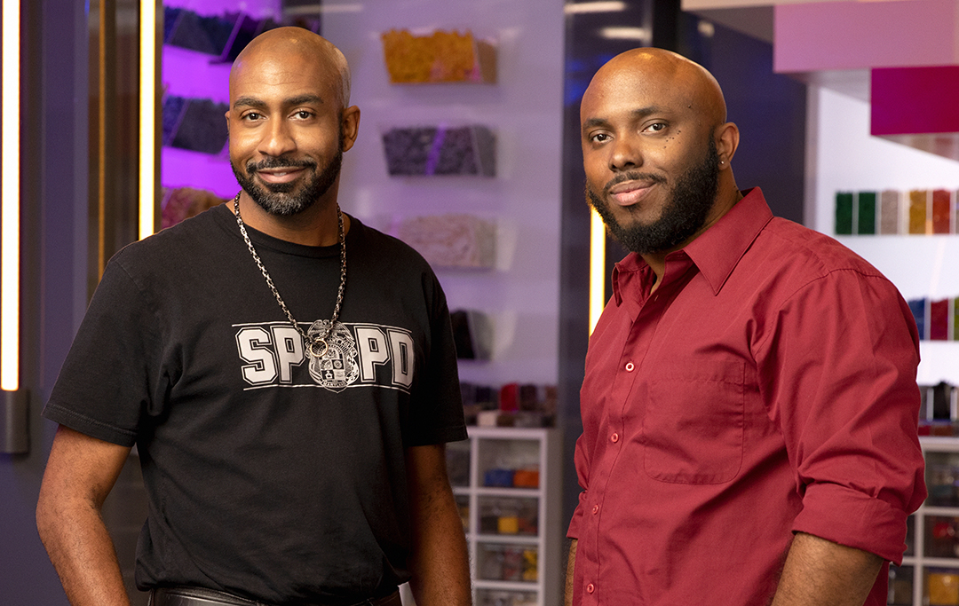 | MEL & JERMAINE  Age: 39 I 37  Home Towns: Glen Burnie, MD / Bronx, NY  Occupations: Law Enforcement / Technical Cell Phone Consultant  Team Name: EAST COAST BRICKSTERS  Strengths: Great storytellers / Tall skyscraper buildings

KRYSTLE & AMIE
Age: 30 I 34
Home Towns: Dallas, TX / Dallas, TX
Occupations: Gaming Designer / Software Engineer
Team Name: THE UNICORNS
Strengths: Great storytelling / Character assembly

-more-

“LEGO MASTERS” MEET THE 20 CONTESTANTS – Page 2

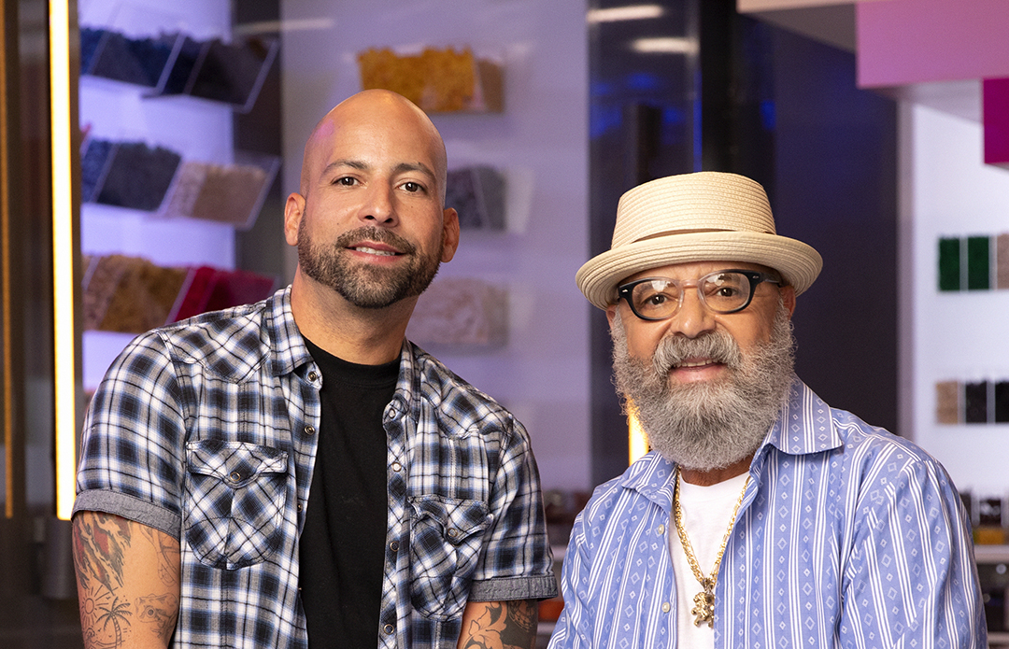 | MANNY & NESTOR  Age: 35 I 65  Home Towns: Bethlehem, PA | Bethlehem, PA  Occupations: Barber / Retired Truck Driver  Team Name: FATHER & SON BFFS  Strengths: Organic builds / Mini-fig character development

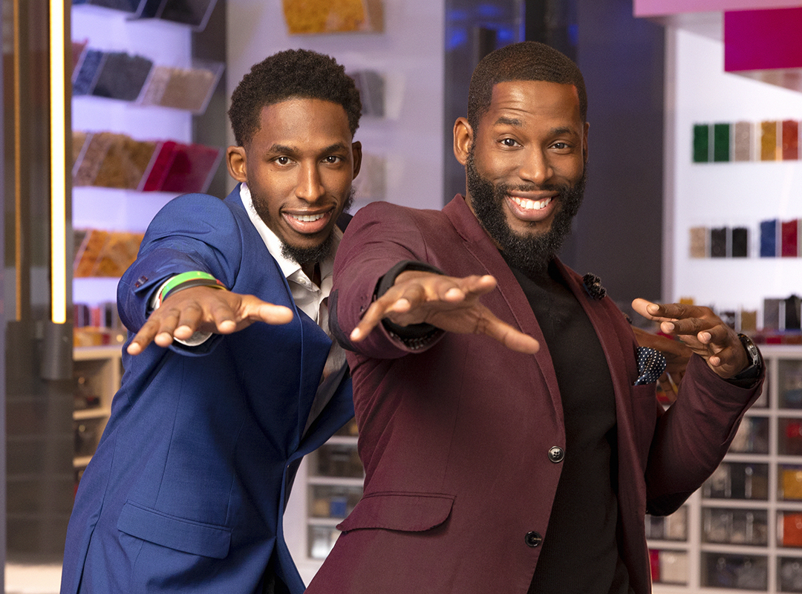 | TRAVIS & COREY  Age: 29 I 34  Home Towns: Irvington, NJ / Monmouth Junction, NJ  Occupations: Preschool Teacher / LEGO Engineering Instructor  Team Name: BROTHERS WHO BRICK  Strengths: Creativity & Ingenuity / Speed

SAM & JESSICA
Age: 45 I 29
Home Towns: Los Angeles, CA / Redding, CT
Occupations: Set Builder / Artist
Team Name: THE ECCENTRICS
Strengths: Ingenuity / Storytelling

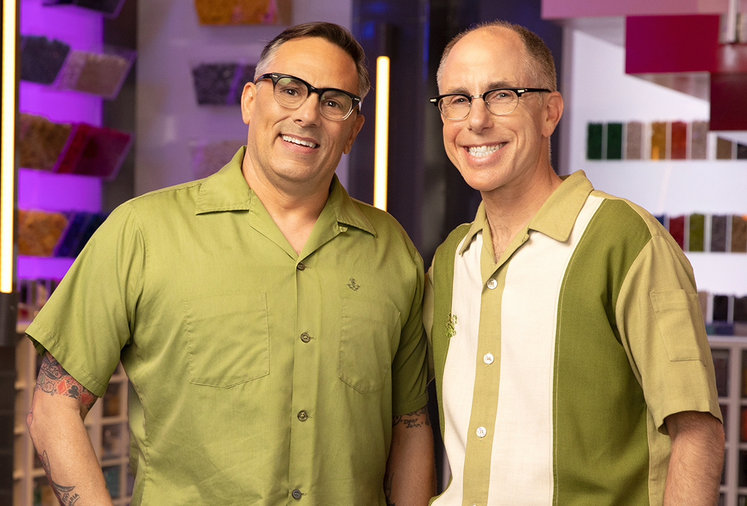 | FLYNN & RICHARD  Age: 52 I 52  Home Towns: Oakland, CA | Oakland, CA  Occupations: LEGO Engineering Teacher K-6 / Theatrical Lighting Designer  Team Name: MARRIED THESPIANS  Strengths: Artistic Look / EV3 builds with sensors and motors

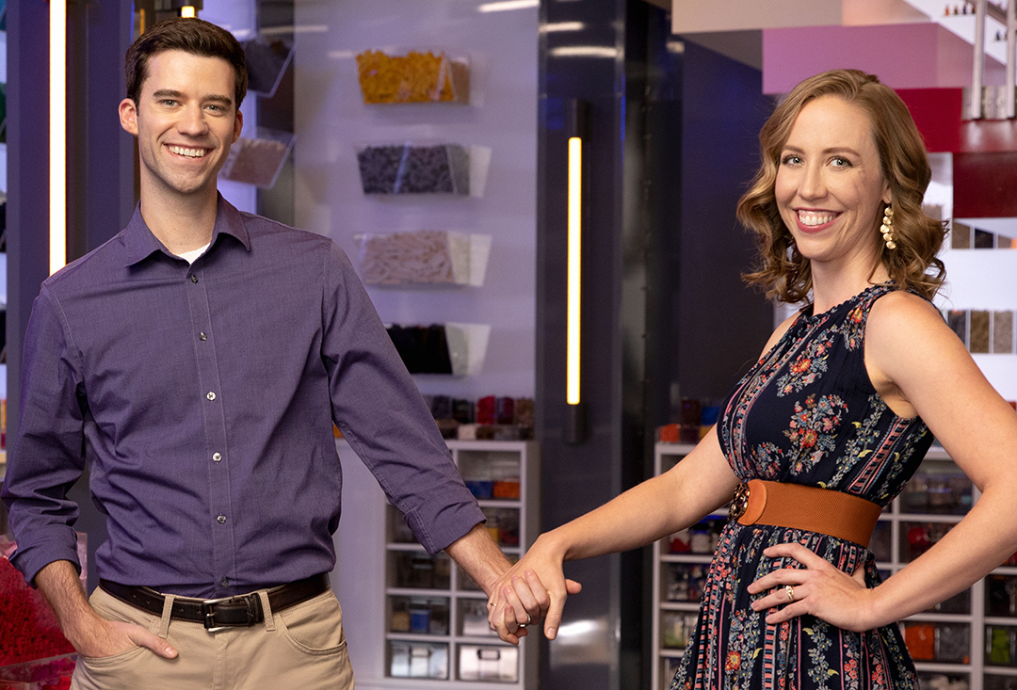 | TYLER & AMY  Age: 32 I 28  Home Towns: Bradenton, FL / Bradenton, FL  Occupations: Model Designer / Piano Teacher  Team Name: THE NEWLYWEDS  Strengths: Sculpting – capturing shape & movement / Resourcefulness

JESSIE & KARA
Age: 48 I 49
Home Towns: Captain Cook, HI / Rogers, AK
Occupations: Administrative Assistant / Retail Manager, Landscape Company
Team Name: THE HIGHER THE HAIR THE CLOSER TO GOD
Strengths: Team Communication / Focus

-more-

“LEGO MASTERS” MEET THE 20 CONTESTANTS – Page 3

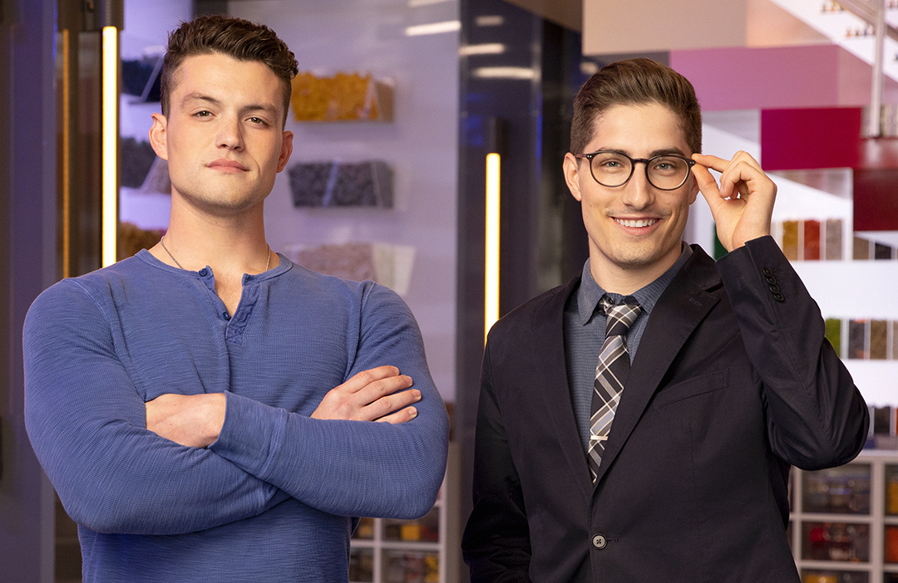 | CHRISTIAN & AARON  Age: 23 I 24  Home Towns: Louisville, KY / Manchester, NH  Occupations: Army Sergeant / LEGO Educator  Team Name: CLARK KENT & SUPERMAN  Strengths: Vehicle builds / Complex shaping

Anthony Dominici will executive-produce the FOX series, along with Sharon Levy, DJ Nurre and Michael Heyerman from Endemol Shine North America; Karen Smith and Steph Harris from Tuesday’s Child; and Jill Wilfert and Robert May from The LEGO Group. Will Arnett also serves as an executive producer.

LEGO MASTERS will be produced by Endemol Shine North America, Plan B and Tuesday’s Child under license from The LEGO® Group, for The LEGO® Group.

About Endemol Shine North America
Endemol Shine North America delivers world-class content and compelling storytelling to multiple platforms in the U.S. and across the globe. Endemol Shine North America is part of Endemol Shine Group, the global content creator, producer and distributor with a diverse portfolio of companies that are behind some of the most prominent hit television formats and series in the world. Endemol Shine Group’s companies in North America are behind hit series such as “Big Brother” (CBS), “Ink Master” (Paramount Network), MASTERCHEF (FOX), MASTERCHEF JUNIOR (FOX), “Swamp People” (History), “The Real Housewives of Atlanta” (Bravo), “Below Deck” (Bravo), “Below Deck: Mediterranean” (Bravo), “T.I. & Tiny: The Family Hustle” (VH1), “Trading Spaces” (TLC), “Deal or No Deal” (CNBC), “LOL” (Amazon) and the upcoming launch of “Utopia” (Amazon), “Extreme Makeover: Home Edition” (HGTV), LEGO MASTERS (FOX), “Súbete a Mi Moto” (Amazon) and “The Biggest Loser” (USA).

About Tuesday’s Child
Tuesday’s Child Television is a U.K.-based independent production company, with offices in London and Glasgow, specializing in entertainment and popular factual. It was launched in September 2012 by Karen Smith (co-creator of “Strictly Come Dancing”), who was a former Shine TV joint MD (“The Magicians,” “Gladiators,” “Got to Dance,” “MasterChef,” “The Biggest Loser,” “Just the Two of Us”).

Tuesday’s Child has recently created and produced two seasons of “The Hit List,” for Saturday nights on
BBC One; “Head Hunters,” a 30-episode quiz hosted by Rob Beckett airing daily on BBC1; reality horror game show “Killer Camp” for ITV2, Channel 4’s fixed-rig social experiment “The Cannabis Café”; two series of the Emmy Award-nominated “LEGO MASTERS“ for Channel 4; BBC One’s entertainment series, “Pitch Battle”; award-winning “You’re Back in the Room” for ITV, and the U.S. version, “Hypnotize Me” (The CW); two series of BBC One daytime series “For What It’s Worth”; “Britain’s Biggest Superyachts: Chasing Perfection” for BBC Two; RTS-nominated series “Superstar Dogs” for Channel 4; “Sean Conway On The Edge” and “Sean Conway: Running Britain” for Discovery; and “How To Build a Robot” for Channel 4.

-more-

“LEGO MASTERS” MEET THE 20 CONTESTANTS – Page 4

About Plan B Entertainment
Headed by Brad Pitt and co-presidents Dede Gardner and Jeremy Kleiner, Plan B Entertainment is an established film and television production company with many acclaimed titles. Their commitment to protecting narrative and giving filmmakers the freedom to take creative risks has resulted in a memorable run of emotionally and socially compelling characters and stories. The company’s titles include THE TREE OF LIFE, WORLD WAR Z, 12 YEARS A SLAVE, THE NORMAL HEART, SELMA, THE BIG SHORT, MOONLIGHT, BEAUTIFUL BOY, IF BEALE STREET COULD TALK and VICE. Most recently, the company released James Gray’s AD ASTRA and will release David Michôd’s THE KING on November 1st.

Along with their development slate, Plan B is currently in post-production on MINARI for A24, BLONDE for Netflix, and in production on Barry Jenkins’ series, UNDERGROUND RAILROAD, for Amazon, and THIRD DAY for HBO.

About The LEGO Group
The LEGO® Group is a privately held, family-owned company with headquarters in Billund, Denmark, and main offices in Enfield, USA, London, U.K., Shanghai, China, and Singapore. Founded in 1932 by Ole Kirk Kristiansen, and based on the iconic LEGO® brick, it is one of the world’s leading manufacturers of play materials. Guided by the company spirit, “Only the best is good enough,” the company is committed to the development of children, and aims to inspire and develop the builders of tomorrow through creative play and learning. LEGO® products are sold worldwide and can be virtually explored at www.LEGO.com. LEGO®, its logo, the Minifigure and the brick and knob configuration are trademarks of the LEGO® Group. ©2019 The LEGO® Group. Used with permission.

-FOX-

